**Python Zero to Hero for DevOps Engineers**

[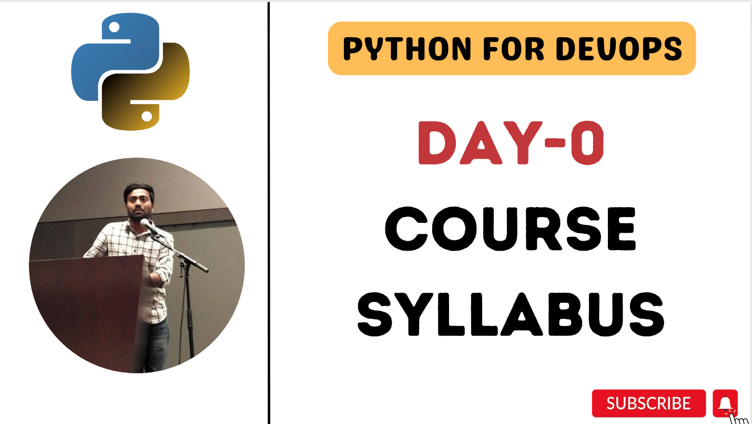](https://private-user-images.githubusercontent.com/43399466/274666662-d70f5fe2-0ba3-449d-b41f-413a38fc4584.png?jwt=eyJhbGciOiJIUzI1NiIsInR5cCI6IkpXVCJ9..MNdbI6nzAq_l2FxKHkZI9T7QCmlynWplXc2f_4vp7Zo)

**Day 1: Introduction to Python, Installation, and Configuration**

* Introduction to Python and its role in DevOps.
* Installing Python and setting up a development environment.
* Writing your first Python program.

**Day 2: Intro to Datatypes, Working with Strings and Numbers**

* String data type in Python.
* String manipulation and formatting.
* Regular expressions for text processing.
* Numeric data types in Python (int, float).

**Day 3: Keywords and Variables**

* Understanding variables in Python.
* Variable scope and lifetime.
* Variable naming conventions and best practices.
* Practice exercises and examples:
  + Example: Using variables to store and manipulate configuration data in a DevOps context.

**Day 4: Functions, Modules and Packages**

* What are differences between function, modules and packages ?
* How to import a package ?
* What are Python workspaces ?

**Day 5: Environment Variables and Command Line Arguments**

* Reading and writing environment variables in Python.
* Using the os and dotenv modules.
* Securing sensitive information in environment variables.
* Handling command line arguments in Python.
* Practice exercises and examples:
  + Example: Developing a Python script that accepts command line arguments to customize DevOps automation tasks.

**Day 6: Operators**

* Introduction to operators in Python.
* Arithmetic, comparison, and logical operators.
* Bitwise and assignment operators.
* Practice exercises and examples:
  + Example: Using operators to perform calculations and comparisons in a DevOps script.

**Day 7: Conditional Handling using if, elif and else**

* Conditional statements (if, elif, else).
* Practice exercises and examples:

**Day 8: Working with Lists (Part 1)**

* Understanding lists and list data structure.
* List manipulation and common list operations.
* Practice exercises and examples:
  + Example: Writing a script to manage a list of user accounts in a DevOps environment.

**Day 9: Loops**

* Loops in Python (for and while).
* Loop control statements (break, continue).
* Practice exercises and examples:
  + Example: Automating a log file analysis with a loop to find errors.

**Day 10: Working with Lists (Part 2)**

* List comprehensions.
* Nested lists and advanced list operations.
* Practice exercises and examples:
  + Example: Print list of files in the list of folders provided

**Day 11: Working with Dictionaries and Sets (Project-1)**

* Dictionaries and key-value pairs.
* Sets and set operations.
* Practice exercises and examples:
  + Example: Managing a dictionary of server configurations and optimizing retrieval.

**Day 12: Python Tasks for DevOps (Part 1) - File Operations (Project-2)**

* Introduction to File Operations and Boto3.
* Automating File operations.
* Practice exercises and examples:
  + Example: Update a server resources in the server.conf file up on external notification.

**Day 13: Python Tasks for DevOps (Part 2) (Project-3)**

* Using Fabric for remote task automation.
* AWS automation with Boto3.
* Managing EC2 instances, S3 buckets, and more.
* Practice exercises and examples:
  + Example: Creating a aws script for deploying applications to remote servers.

**Day 14: Github-JIRA intergration Project - (Project-4)**

* Introduction to RESTful APIs.
* Making HTTP requests using Python.
* Parsing JSON responses and error handling.
* Practice exercises and examples:
  + Example: Write a Python API which listens on a github comment and creates a ticket in JIRA.

**Day 15: Github-JIRA intergration Project - (Project-4) - (Part-2)**

* Introduction to Flask.
* Write your first API in python.
* How to handle API calls and deploy your API to a server.
* Practice exercises and examples:
  + Example: Write a Python API which listens on a github comment and creates a ticket in JIRA.

**Day 16: Python Interview Questions & Answers**

* Beginner and intermediate Level

**Day 17: Python Interview Questions & Answers**

* Advanced Level